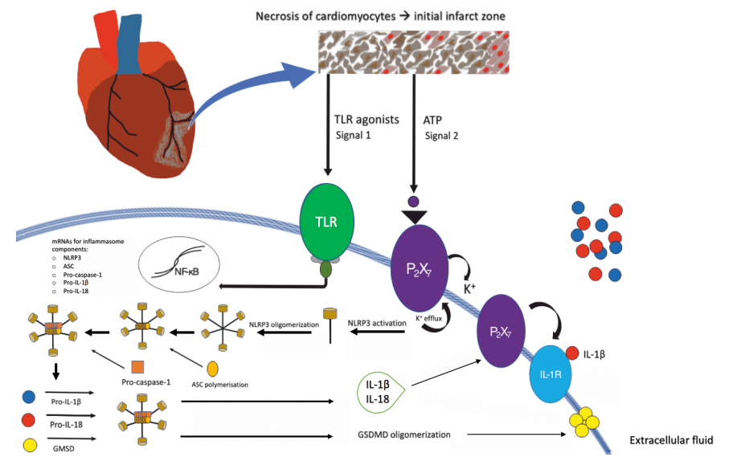
Figure 1. The molecular signalling leading to the Nod-like Receptor Family Pyrin Domain Containing 3 (NLRP3) inflammasome assembly is illustrated. This is initiated by myocardial infarction. Necrosis of cardiomyocytes form the initial infarct region. Signal 1 (priming signal) in the form of a toll-like receptor (TLR) agonist, activates the TLR, causing mRNA synthesis for NLRP3 inflammasome components; NLRP3, adaptor protein apoptosis-associated speck-like protein containing CARD (ASC), pro-caspase-1, pro-interleukin-1β (pro- IL-1β), pro- interleukin-18 (pro-IL-18). Adenosine triphosphate (ATP), acting as a trigger signal (signal 2), activates P2X7 ATP channel to cause potassium (K+) efflux, leading to NLRP3 activation and oligmerisation. Following ASC polymerisation and pro-caspase-1 recruitment, the inflammasome complex is assembled. Cleavage of pro-caspase-1 into caspase enables cleavage of pro- IL-1β and pro- IL-18 into IL-1β and IL-18 and GSMD oligmerisation. NLRP3-inflammasome assembly has two consequences (1) IL-1β and IL-18 exits the cell through P2X7; IL-1β autocrine signalling is mediated by interleukin-1 receptor (IL-1R) (2) GSMD oligmerisation enables pore formation in the plasma membrane, thought to
mediate pyroptosis. Adapted from [33] and [34].

